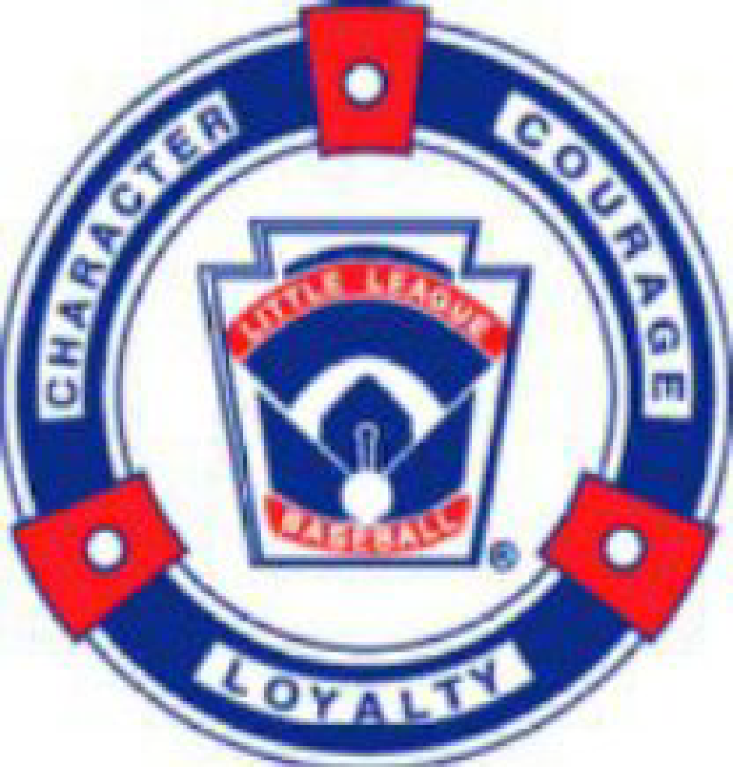

**High Plains Little League (HPLL)**

**12/16/2024 Board Meeting Agenda**

**Klimek House, Falcon, CO**

**12.16.1: Call to Order 6:02 pm**

**In Attendance: TJ Hartley, Jared Holtz, April Holtz, Jeff Klimek, Kristina Johnson, Kevin Carpenter, Ashley Carpenter, Bobbi Lehman, Krista Bower, Carey Jones, Jackie Reed, Brett Reed, Doug Ziegler, Gina Klimek, Tyler Chubb, Taryn Chubb**

**12.16.2: Meeting Minutes Sent via Email for approval Nov Meeting—all approved**

**12.16.3: Treasurer update:**

* Address remaining 2024 financial questions.

Did you see the email Jared sent? Questions? Bobbi—Breakout, reg in person, all stars, fall clinic—help with costs, separate more. Line items keep in categories. Fundraising dine in—league in general. Golf is for All Stars.

Carey—Spreadsheet. per season, per person per division—to forecast, so possible working budget

Broke out by season. Players, field costs etc. Overhead-2 categories, fees & equip. Nice to add a category—overhead.

Jared will get the cost data for Carey. Goal for next meeting

Tyler—requirement receipts. Need to vote on expenses. Was asking for all receipts for 90 days.

Tj—cannot inforce a protocol and it cannot be done overnight. What is the motive? Tyler says no motive. April asked why we couldn’t buy from amazon. Bobbi—we are working on this. Jared have all receipts, requested the ones missing from Walmart.

Talked about A digital form to approve purchases—audit committee can approve & Tyler as signer.

Are we going to have a petty cash—what is limit. Limits are Based on the Budget—field maintenance—go get it as long as it is within the budget. Purhase - . Immidiate needs are approved. Reimbursement—things with prices within the budget.

Equipment-if over budget, then you need approval. We will come back once we have a budget.

We need to break down the detail a little more from the financials entered into quickbooks.

Talking about a Drop Box, Share Point….something we can all access for documents, etc.

* Current account status—Still working on closing Farmers and moving to ENT
* Accountant discussion—

Becky is who Jared has been talking to. 3 plans--$227-$747 per month. Jared recommends the high plan to get our books up to date. Then could back off and go quarterly.

Fed Status is approved. File taxes. Grants we can apply for once all is caught up.

Bobbie asked for profit prior years. Don’t have that yet. Minutes are on the website back to at least 2019. What can we shoot for for profit goals. Guidance for budget – last years numbers & add some to it. Basically a working budget…

Receipts-picutres or scanned copy to Gina’s email.

Amazon business account – times for shipping differs.

Non-Profit Walmart—smile tax free. Sams card that is tax free.

Gina did a motion for High plan accountant—Jackie 2nd motion. Month to month comprehensive and all approved for now.

She will come to the board meetings

* Bank Status and update—heading in the right direction. Farmers 68093.94 Ent 20619.89

Registration going to ENT. Farmers is still open. Tyler will be added to ENT this week.

Purchase card for members that need to make regular purchases. Limits on them.

Form is for reimbursement--

Jeff doesn’t want a purchase card. Preapproval is for big ticket items not on the Budget.

Jim as the treasurer will have to be responsible for the line items we spend on.

* Working Budget will help decide if we need to raise registration, and if we are raising it is because we are saving for X

**12.16.4: Registration update:**

* Current Numbers for registration 157 registered.

April said she wants to say Ashley is a big deal—new softball girls from fall skills clinic. 2 teams to 5 teams. We will be even bigger this year. Thank you.

* Hats/Jersey Supplier Update—ordered hats for spring 1st wk nov. $9.15 were $9.85 last year. Hard to find a non-middle man. Call from guy who will do Jerseys for $11 each. 2023 $25 per piece. 2024 $25 youth, 35 adult. Avg 31.19 per jersey. We think they will be good—out of Kansas City. They only use sublimation. Spiritwear will still need a screen printer. Looks like we can keep our sponsors on the shirts.

**12.16.5: Facilities for 2025**

* D49 Field Rental requests going in 1/1/25—having us wait till 1/1/25 1st come 1st serve. Along with PLC small
* DBat Tryouts Feb 22nd, Good For Spring practices—

Lunch with presidents & Mike tomorrow—Dion is there and owns d-bats

* Coaches Clinic - Tentatively March 8th - Location to be finalized—Waiting to hear from Vibes.

4/5/25 uniform pick up & pictures. Meridian or bennett ranch here in Falcon

**12.16.6: Equipment**

* Jeff - Status to order for spring season

Sheels came back and gave us a discount. Total $3985.94 for what he needs. 40 doz BB 4 doz Tourney BB, 20 catcher mitts, 22 Tees. Gift Card for $2000 goes into effect on 1/1/25. No diamond BBs

Softballs—no 80s star. 6doz 11” 6 doz 12”. Budget with softballs $4443.XX

Softball Fielders masks 1 or 2 extra for Softball girls. Part of Equipment bag. 3-4 years ago, bought for all. $39.99 is avg. $480 approximately for the year. Can we use the old and supplement with half new and half old. No Dicks sporting goods softballs.

Chalk was about $1100. New chalkers are not in the budget. $250 approximately per chalker. 2 are good. Min of 4 total.

Jeff will work on final numbers and send it to the board

* Girls with Game Grant - Decisions for Softball purchases needed by 12/31/24

Growing softball & bigger participation. $5000 grant. Detailed report to Little League

League up and coming. No indoor facilities. Geared to what equipment and facilities. Proposed items to buy: Team Bats, 18 in different sizes. 10 tees. 10 hitting nets. 4 Catchers gear, 10 bags. $3103.70 at Scheels. Spring practices at woodmen Hills instead of Dbats. $20 per hour. Inflatable batting cage – weight & storage is the issue. Otherwise bigger nets and L-screens. Money is going back into the community. Entire year rentals at Woodmen Hills. This takes her to $10 over the $5000. She would ask for league to pay taxes about $154.00.

Daniels fund – no news now. El Pomar-no news now. We already have the money in ENT for Softball Grant.

Jeff approves the tax amount, TJ 2nds it. Approved if about $154. Can come out of Equipment budget.

Sunbelt said they will donate vehicle if a place to keep it. We need a 2.nd connex. Someone will donate. Lawnmower was offered.

Lip on white field needs to be fixed. Jared will reach out to county.

**12.16.7:** **Misc Discussion topics**

* Coachs - Pairing 1 assistant coach pre-draft?

TJ—going into draft have 1 assistant coach. Spread the talent throughout the teams. Manager & 2 assistant’s is 3 kids already for the teams. Ashley—draft, why. Newer coaches come with less talented kids typically. Top kids are usually gone with coaches. Trying to level the playing among the teams. Spreading talent. Makes us more competitive. Make them unbiased while assessing the kids. We tried having the same people assessing for all levels. Coaches don’t necessarily take top kids/take friends.

A person on the bench with kids is required.

8 in favor. 6 opposed. Approved we are going to try it.

* Draft idea/proposal - Ranking at evals based—helps new coaches.

Coaches should come to evals. Can revisit.

* Email follow up discussion(Doug) ??
* Sponsorship Updates-

$18000 in sponsorship. All div covered. All banners are still good. So 4 reusable (same sponsors). Possible roofing company & ENT.

**12.16.8: Open Discussion**

* Emails personal vs HPLL

Doug—domain. Highplainsll.com office 365—10 free accounts.

Migration—donate time to help with that. Dougs people would just want a banner/sign at the field for the donation of time to do this task.

Would have a shared drop file. Jeff made a motion—will keep open. Meeting with his people.

* Next Board Meeting 1/9 - Holtz House 6 pm

1/7/25 Dions dine in date

1/20/25 swirly cow in person registration

6/8/25 - 1 pm rockies vs mets youth date

* Open Discussion

Adjourned at 8:02 pm